April 6, 2020

Dear Parents,

Ms. Duffy and I will both be using the resource Epic! for all your children’s reading needs. Please note this is only an additional resource for your children to use. If they want to read their own materials at home, they certainly can do that as well.

Instructions:

- Go to www.getepic.com/students
- Enter your class code vyu7884 (case sensitive)
- Click on your name (it is not password protected so we have to remind them to be respectful of other students profiles)
- Choose your book and how you want to read it!

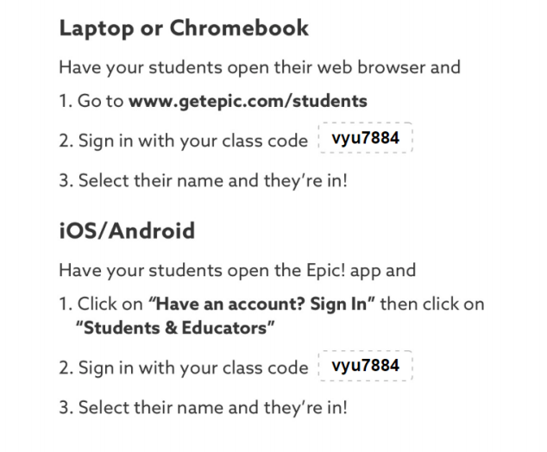
Additional Information for different applications:

