QUICK WRITES
“April Showers Bring May Flowers”
Materials: Paper, pencil and timer
Step 1: Students choose one quick write idea to write about
Step 2: Set timer for 3 minutes
Step 3: Write about your topic. Try to write the entire time, do not erase
Step 4: Share with someone at home

You are a drop of rain. Describe your life | Describe the smell of spring | You are a goose. Describe your trip north in the spring
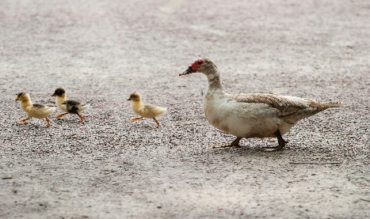 | A flower and a weed are in your garden having a conversation. What are they saying? | Write down three or more facts about frogs or toads
Describe spring using all five senses (sight, hearing, touch, smell and taste) | If you were in charge of a garden, what would you grow? Why?

