Grade 7 Math
In Class Assignment

Section A – Multiple Choice. Circle the correct answer for each. Show your thinking with an example. (10 marks)

- The sum of two opposite integers is always zero.
- True B) False
Example:_____________

- The sum of two positive integers is negative.
- True B) False
Example:____________

- The sum of two negative numbers is negative.
- True B) False
Example:_________

- The sum of a negative and a positive integer is always positive.
- True B) False
Example:__________

- Zero pairs are shown by equal amount of tiles for a nega.
- True B) False
Example:________

Section B – Representing integers
Use labelled tiles to represent each sum.
*Remember to circle your zero pairs!

- (+4) + (-9) = b) (-5) + (+3) =

- (-2) + ( -3) = d) (+ 12) + (-2)=
Section C – Adding Integers on a Number Line
You may draw 1 or 2 arrows to represent the addition equation.

- ( +2) + ( +4)

- (-3) + ( -4) =

- (+2) + (-5) =

- (-9) + (+4) =

Section D- Write the addition equation that is represent by the following number lines.

- 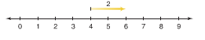

Equation:_____________________

- 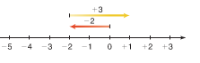

Equation:_____________________

- 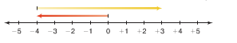

Equation:______________________

- 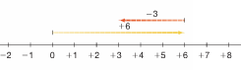

Equation:______________________

- 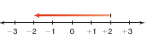

Equation:______________________

Section E
Create an Integer equation for the following statements.

- The temperature drops 2 C then rises 4 C.
________________

- Marie earned $ 7 and then spent $3.
________________

- Grady walked 10 steps forward then 3 steps backward.
_______________

- Ty deposits $20, then withdraws $10.
_______________

- Laura drove her bike 2 km left then turned around and drove 1 km right.
______________

Section E
Draw each of the following to arrive at the correct answer. You may have to add or take away tiles to arrive at the answer.

- You have 10 red tiles.
How can you show -2?

- You have 10 positive tiles.
How can you show +2?

- You have 10 red tiles.
How can you show +2?

- You have 10 yellow tiles.
How can you show -2?

- You have 10 yellow tiles.
How can you show 0?

Section F
Match.

- (-2) + (+3) -1
- (+2) + (+3) +1
- (-2) + (-3) +5
- (+2) + (-3) -5

