Weekly Math Homework
May 29 to June 2

Monday:
- Which rectangle has the greatest area? Show your work

- Rectangle A: Length 20 cm, Width 5 cm
- Rectangle B: Length 13 cm, Width 12 cm
- Rectangle C: Length 36 cm, Width 9 cm

- Mike’s rectangular garden is enclosed with 24 m of fencing.

- What is the least possible area of Malika’s garden?
- What is the greatest possible area?

Tuesday:
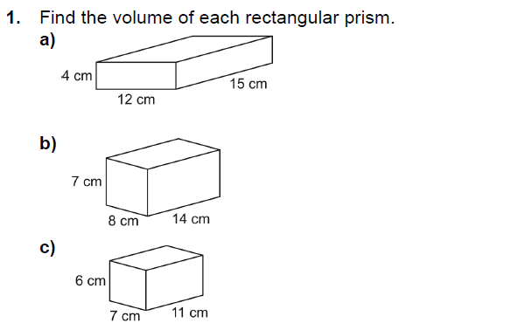

Wednesday (Review)
- Draw a picture to represent each number
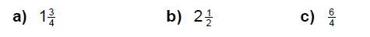

- Write each improper fraction as a mixed number

- Write each mixed number as an improper fraction

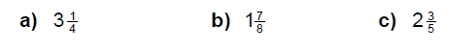
Thursday: (Review)
Multiply: (remember to estimate first)

