May 15-19

Monday:
Multiple Choice:
- Can a convex polygon be an irregular polygon?
- True
- False

- Can a right triangle be an isosceles?
- True
- False

- Can a concave polygon can have more than one 180 degree angle?
- True
- False

- Can a triangle have angles of 78◦, 100◦ and 3◦
- True
- False

For any questions that you answered false, write the correct answer

Tuesday:
Draw the following shapes

- Polygon d. Regular polygon

- Concave polygon e. Convex polygon

- Irregular polygon f. Non polygon

Wednesday:
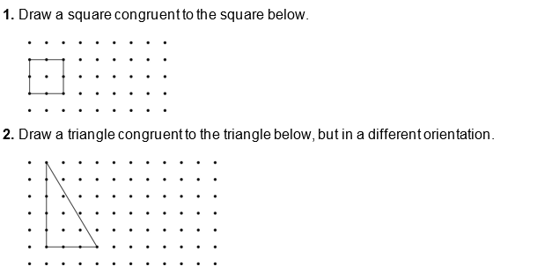

Thursday:
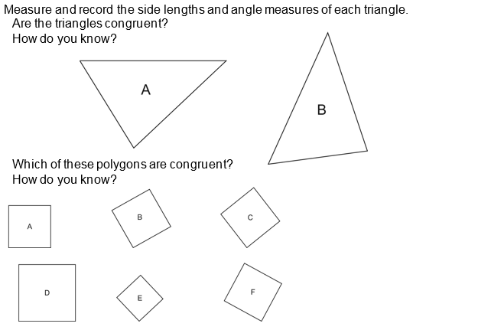
1.

2.

