Weekly Math Homework
May 8-12
Monday:

- Find pairs of triangles that are of the same type. Name the type of triangle each time.
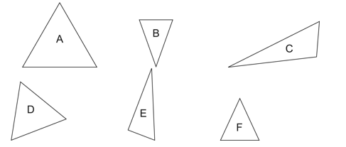

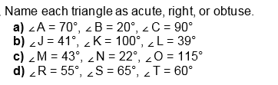

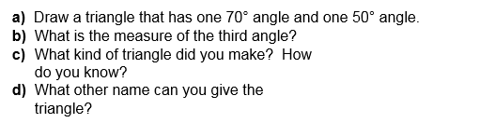
Tuesday:

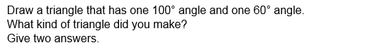

Wednesday:
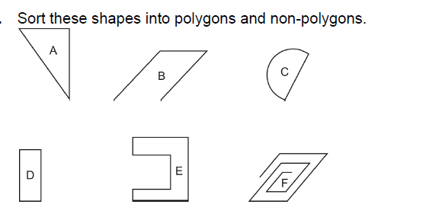

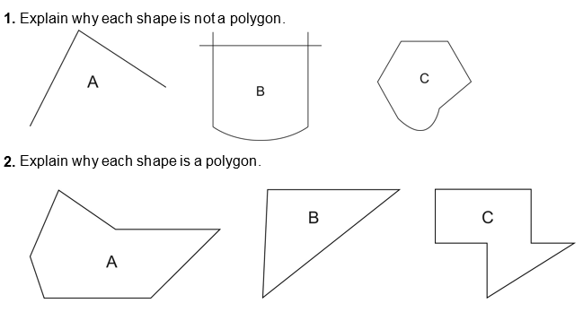
Thursday:

