Homework
May 1-3

Monday:
- Two angles of a triangle are given. Find the measure of the third angle. Remember to show your work.

- 65°, 25° b. 30°, 60°

- Three angles of a quadrilateral are given. Find the measure of the fourth angle. Remember to show your work.

- 45°, 100°, 75° b. 25°, 130°, 100°

Tuesday:
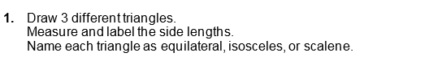

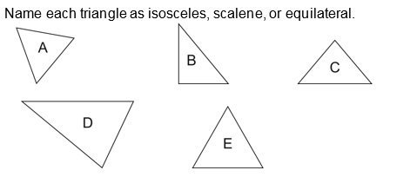
2.

Wednesday:

