WEEKLY MATH HOMEWORK
March 20 to 24

MONDAY

2. A paper bag contains 3 green marble, 5 yellow marbles and 2 red marbles. Mark draws a marble without looking.

- List the possible outcomes.

- What is the theoretical probability that the tile is:

Green?

Yellow?

Not Red?

TUESDAY
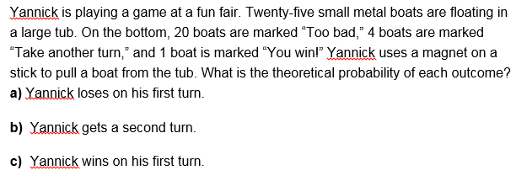

WEDNESDAY
Reflection:
How do the experimental probabilities compare with the theoretical probabilities? Explain. (Use pictures, words and numbers)

THURSDAY
Review:
