Weekly Math Homework
March 13 to 17

MONDAY
- What answer would you give to the question above?

- Explain why?

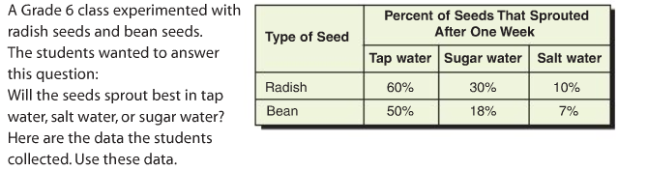
- What conclusion can you make?

- Why do you think this might be?

TUESDAY (Review)
Multiply the following Decimals. Estimate first
Example: 4.5 x 6
Estimate: 4 x 6 = 24 (Remember this helps you place the decimal)
40 x 6 = 240
5 x 6 = 30
Total 240 + 30 = 270
Answer 4.5 x 6 = 27

- 3.4 x 6 b. 8.2 x 4

WEDNESDAY

- List the possible outcomes?

THURSDAY
- Reminder that your survey assignment is due tomorrow

