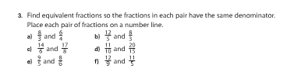

If students did not bring their number lines home they can either make new ones or print them off again.

