MONDAY: (MULTIPLICATION)
All corrections must be written out 10 times each
2 x 4 = | 11 x 2 = | 9 x 0 = | 7 x 4 =
4 x 5 = | 12 x 12 = | 10 x 4 = | 8 x 6 =
3 x 8 = | 2 x 9 = | 11 x 1 = | 9 x 4 =
5 x 5 = | 3 x 3 = | 12 x 5 = | 10 x 4
6 x 3 = | 4 x 7 = | 2 x 6 = | 11 x 9 =
7 x 8 = | 5 x 9 = | 3 x 1 = | 12 x 4 =
8 x 9 = | 6 x 4 = | 4 x 11 = | 2 x 12 =
9 x 10 = | 7 x 1 = | 5 x 12 = | 3 x 7 =
10 x 7 = | 8 x 9 = | 6 x 11 | 4 x 9 =
11 x 3 = | 9 x 9 = | 7 x 4 = | 5 x 6 =

TUESDAY: (REPRESENTING)

WEDNESDAY: (CONVERTING)
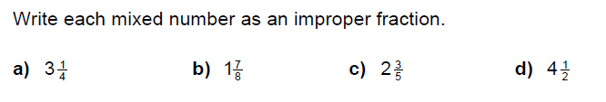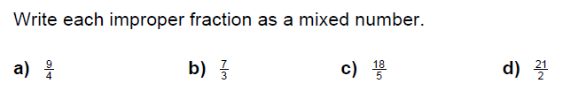

THURSDAY: (COMPARING)
