Monday:
- Write as a percent. Then write as a decimal.
- 37 out of 100 b. 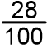 c. 13 : 100

2. Write each fraction as a percent AND as a decimal.
- 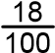 b. 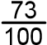 c. 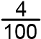 d. 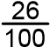

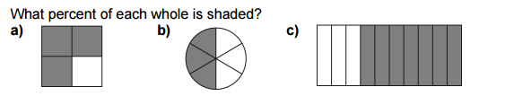
Tuesday:

Percent: __________ Percent ________ Percent ________
Show Your work.

Wednesday
Write each percent as a decimal AND as a fraction.
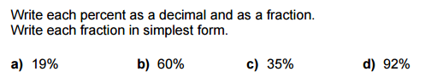
Write each fraction in simplest form.

Word Problems:

In a survey 1 in 5 people said they prefer Coke over Pepsi. What is this figure as a percent?

