Monday Comparing Fractions
- Show your work with pictures and words
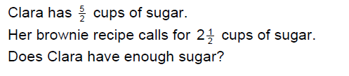

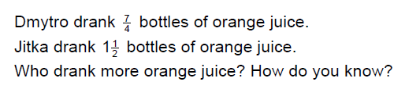

Tuesday Comparing Fractions
- Show your work.
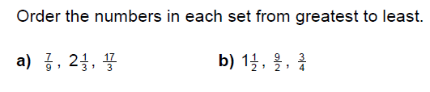

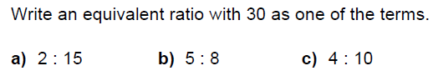
Wednesday Ratios

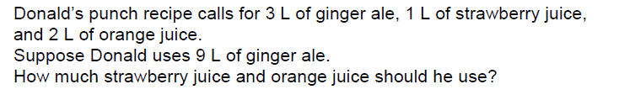

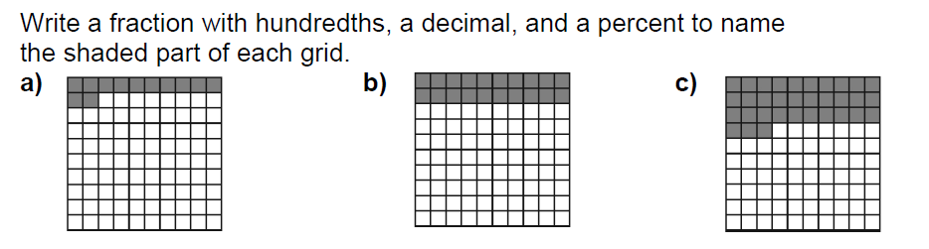
Thursday Percent

