Homework
Feb 6 – 10
MONDAY:
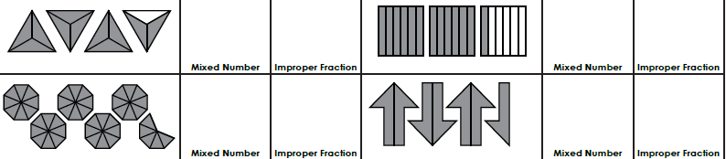
Representing

Converting

e. f. g. h.

TUESDAY:
Comparing (Order the following numbers from greatest to least)
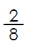
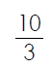
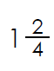
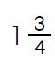
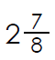
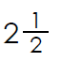
- b.

WEDNESDAY:
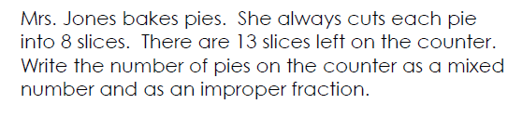
Problem:
a.

b.

THURSDAY:
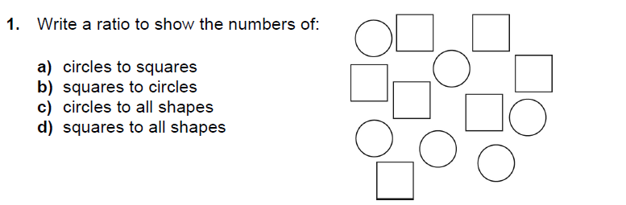
Ratios

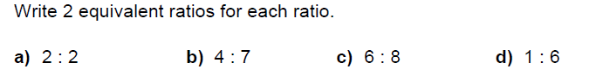
2.

