Weekly Math Homework
April 10-13

Monday:
- What time might it be when the hour hand and minute hand on a clock form:

- A right angle? c. A straight angle? e. A Reflex angle?

- An acute angle? d. An obtuse angle?

- Use a ruler. Draw and label the following angles: Acute, Obtuse and Reflex

Tuesday:
For each angle:
- Choose an appropriate reference angle: 45 ◦, 90◦, 180◦ to help estimate the size of the angle.
- Use a protractor to find the angle measure.
- Name each angle as acute, right, obtuse or straight.

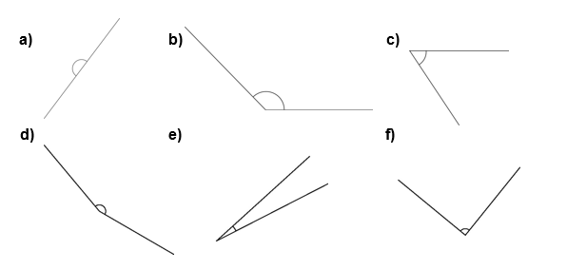

Wednesday:
- Use a ruler and a protractor. Construct an angle with each measure.

- 15◦

- 75◦

- 105◦

- Use a ruler and a protractor. Construct an angle with each measure.

- 280◦

- 345◦

