Monday:
Review
- Write 10 composite numbers

- Write 5 prime numbers

- Write 5 equivalent ratios for the following terms

- 2 : 5

- 7 : 3

- 12 : 9

Tuesday:
- Identify if the following expressions are communitive. Explain why and why not

- 6 x 7

- 8 + 4 + 3

- 6 – 7

- Are these expressions balanced? If not, make them balance.

- 8 + 8; 9 – 8 + 10

- 49 – 2; 1 x 47

Wednesday:

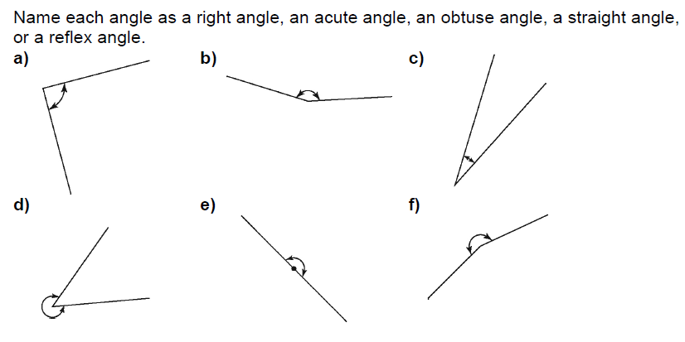

- Where might you find an example of a right angle in your home?
How could you check that it is a right angle?

Thursday:
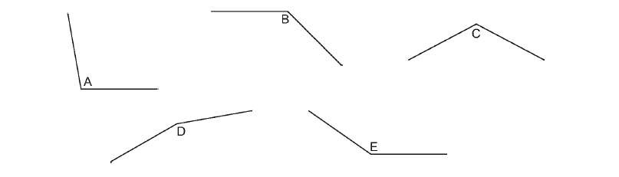
- Look at the obtuse angles below.
- Measure the angles with your protractor.
- Order the angles from least to greatest.

