Monday:

Find the missing angle.

1. 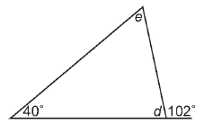 c. 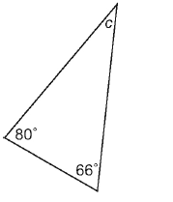

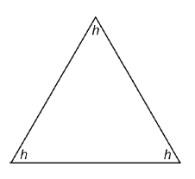

1. 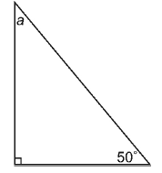 d.

Tuesday

Find the measure of the third angle in each triangle.

1. A triangle with 2 angles measuring 110®and 45®
2. A triangle with one right angle and a 40® angle
3. A triangle with two angles measuring 60®

Wednesday:

1. 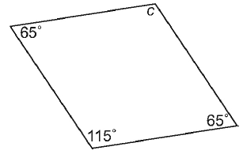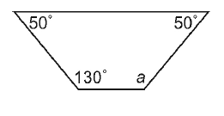 c.

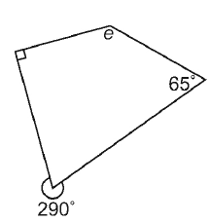

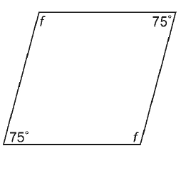

1. d.

