Week Math Homework
April 18-21
Tuesday:
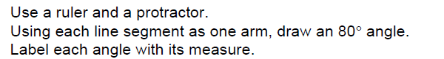

Wednesday:
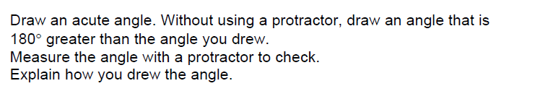

Thursday:
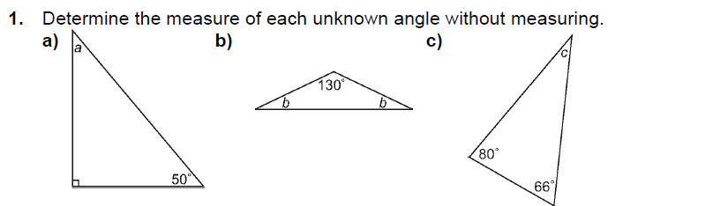

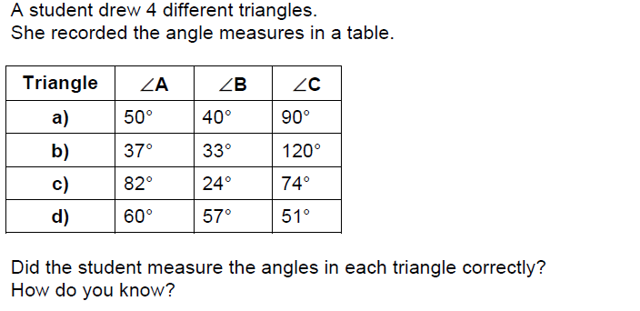
2.

