**Weekly Homework**

**Sept 26-30**

**Parents Signature: ___________________**

**MONDAY**



**Tell me a real life situation when you would use:**

1. Written numbers
2. Standard numbers

**TUESDAY (You may use a calculator but show your work)**



**WEDNESDAY**

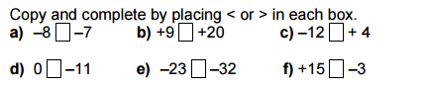

**THURSDAY**

