Math Homework Sept 19-23
Parents/Guardian Signature: _______________________

MONDAY: 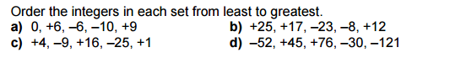
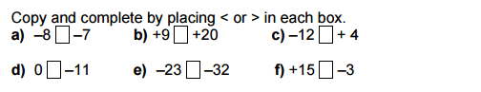

TUESDAY:
Order these elevations from highest to lowest.
Caspian Sea Shore 28 m below sea level
Elbrus, Russia 5642 above sea level
Lake Assal, Djibouti 156 m below sea level
Eurasia Basin, Artic Ocean 5450 m below sea level

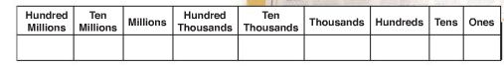
WEDNESDAY:
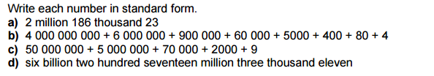

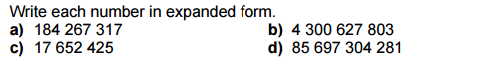

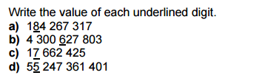
THURSDAY:

******DON’T FORGET LAST WEEKS CORRECTIONS******

