Weekly homework
Nov 14 to 17

Monday:
Number of Flowers | Number of Pedals
2 | 12
4 | 16
6 | 20
8 | 24
- Write the pattern rule that relates the number of flowers to the number of pedals.

- Write the expression for the pattern rule

3. Predict what the number of pedals are if you have 16 flowers.

Tuesday:

- Write an expression for the following pattern rules:

- A number that doubles and subtracts 4
- A number that triples and multiples 7
- A number that divides by 15 and subtracts 3

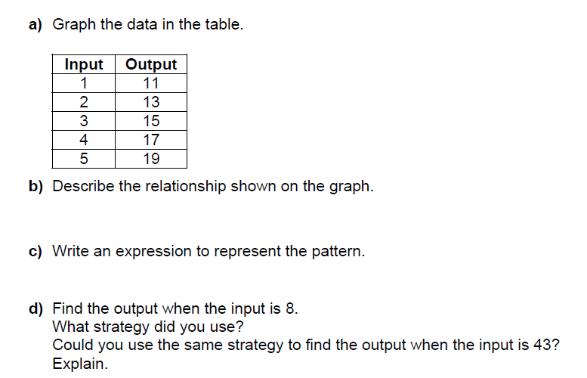

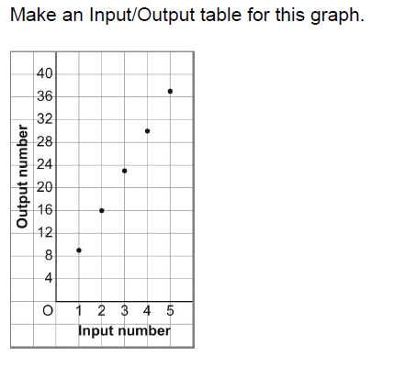
Wednesday:

- Orders of operation.

- 6 + 3 x 5

- 5 – 2 + 5

- 14 x 2 ÷ 4

- 10 + 7 x 3 – 2

- 30 x 2 – 10 ÷ 2

