Monday:
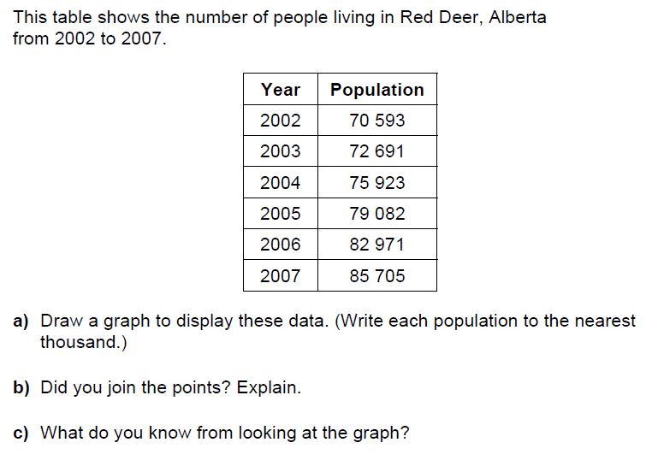

Tuesday:
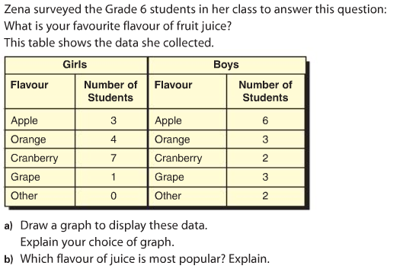

Wednesday:
Millions | Hundred Thousands | Ten  Thousands | Thousands | Hundreds | Tens | Ones | Tenths | Hundredths | Thousandths | Ten Thousandths | Hundred Thousandths | Millionths
1 | 2 | 3 | 5 | 8 | 9 | 3 | 2 | 0 | 7 | 9 | 0 | 4

Example:
1 000 000 + 200 000 + 30 000 + 5000 + 800 + 90 + 3 0.2 + 0.00 + 0.007 + 0.0009 + 0.00000 + 0.000004
Write the following digits in expanded form.
- 45.678

- 0.678 91

Using any or all of these digits 1, 0, 2, 0, 4, 0, 5, 0
- Write 5 numbers less than one thousandths

- Which of your numbers is the least? How do you know?

Thursday:
Multiply the following decimals (estimate first so you know where to place your decimal)
- 4.56 x 8 =

- 56.787 x 2 =

