Math Review May 12

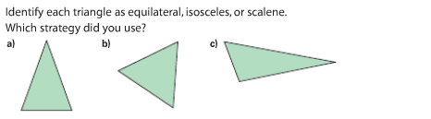

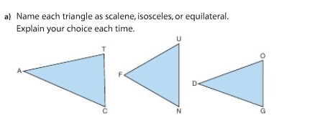

- Find the expression.

- 49 ÷ 7 – 2 b. 70 + 9 – 3 c. 6 x 10 ÷ 2

d. 4 - 2 X 10 e. 6 + 5 + 4 f. 8 – ( 2 x 1)

