Homework
May 2 – 4

Monday:
- Two angles of a triangle are given. Find the measure of the third angle. Remember to show your work.

- 55°, 105° c. 30°, 60°

- 45°, 90° d. 25°, 125°

- Use a ruler and a protractor. Construct an angle with each measure.

- 125°

- 320°

Tuesday:
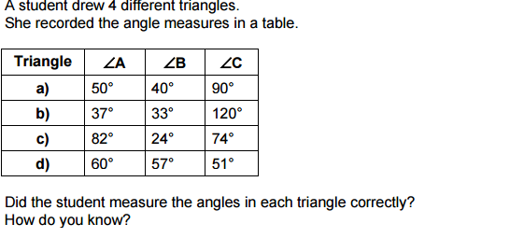

Show Your Work

- Determine the measure of each unknown angle without measuring.

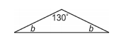
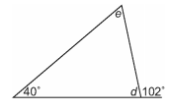
c.
