WEEKLY MATH HOMEWORK
March 21-24
*Homework is due Thursday this week, not Friday

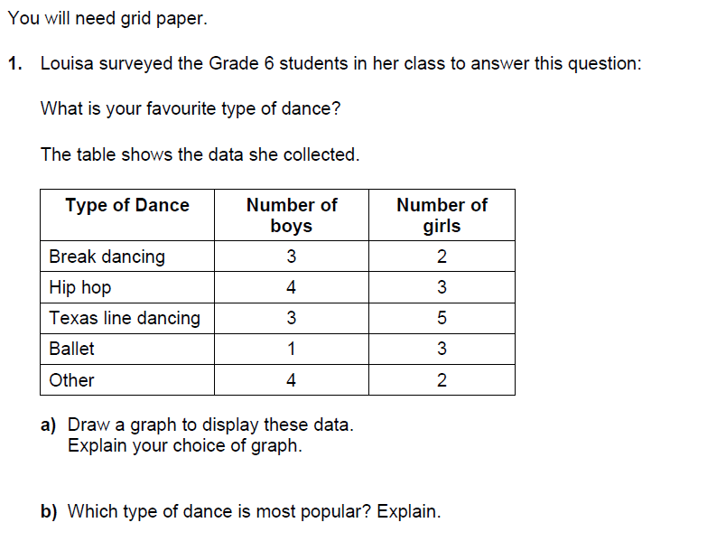
MONDAY

TUESDAY

2. A paper bag contains 3 green marble, 5 yellow marbles and 2 red marbles. Mark draws a marble without looking.

- List the possible outcomes.

- What is the theoretical probability that the tile is:

Green?

Yellow?

Red?

WEDNESDAY
