MONDAY:
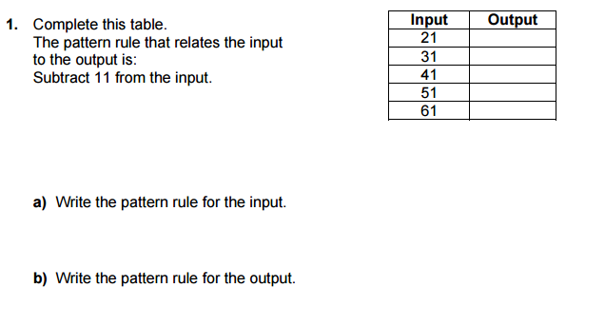

TUESDAY:
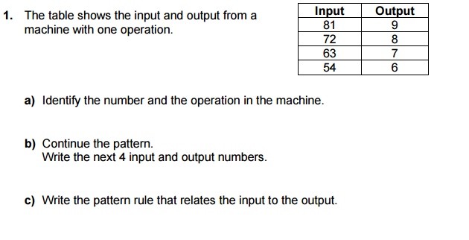

WEDNESDAY:
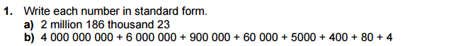

3.

THURSDAY:

