Name: _________________________ Parents Signature: ___________________________
Monday:
- Evaluate each expression. (Use the order of operations rules)

- 3 + 5 x 4 = b. 15 – 6 + 2 = c. (9 – 4) x 4 = d. 7 x 3 – 3 x 4 =

Tuesday:
Problem #1
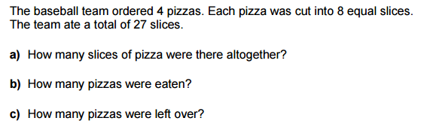
(Draw a picture to help your show your solution)

Problem #2

Wednesday:

Thursday:
