Name: _________________________ Parents Signature: ___________________________
Monday/Tuesday
3 x 5 = | 12 x 7 = | 10 x 10 = | 8 x 4 =
4 x 6 = | 2 x 8 = | 11 x 9 = | 9 x 12 =
5 x 9 = | 3 x 9 = | 12 x 6 = | 10 x 0 =
6 x 9 = | 4 x 4 = | 2 x 5 = | 11 x 7 =
7 x 3 = | 5 x 7 = | 3 x 4 = | 12 x 8 =
8 x 8 = | 6 x 7 = | 4 x 9 = | 2 x 11 =
9 x 9 = | 7 x 7 = | 5 x 0 = | 3 x 11 =
10 x 12 = | 8 x 7 = | 6 x 7 = | 4 x 8 =
11 x 11 = | 9 x 7 = | 7 x 5 = | 5 x 5 =
12 x 4 = | 10 x 6 = | 8 x 6 = | 6 x 9 =
2 x 4 = | 11 x 2 = | 9 x 0 = | 7 x 4 =
4 x 5 = | 12 x 12 = | 10 x 4 = | 8 x 6 =
3 x 8 = | 2 x 9 = | 11 x 1 = | 9 x 4 =
5 x 5 = | 3 x 3 = | 12 x 5 = | 10 x 4
6 x 3 = | 4 x 7 = | 2 x 6 = | 11 x 9 =
7 x 8 = | 5 x 9 = | 3 x 1 = | 12 x 4 =
8 x 9 = | 6 x 4 = | 4 x 11 = | 2 x 12 =
9 x 10 = | 7 x 1 = | 5 x 12 = | 3 x 7 =
10 x 7 = | 8 x 9 = | 6 x 11 | 4 x 9 =
11 x 3 = | 9 x 9 = | 7 x 4 = | 5 x 6 =

Wednesday/Thursday
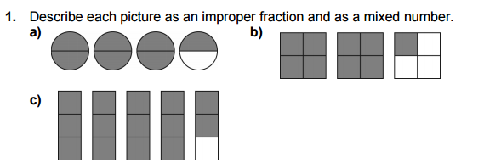

Answers:
a.

b.

c.

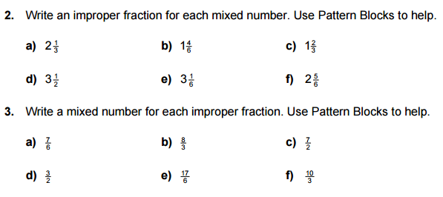

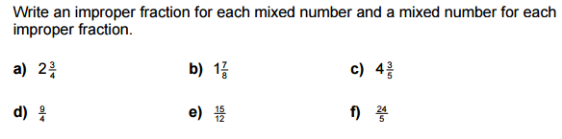
4.

