Monday (Comparing Fractions)
1.

2.

Tuesday (Comparing Fractions)
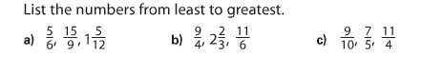

Wednesday (Ratios)
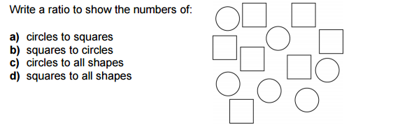

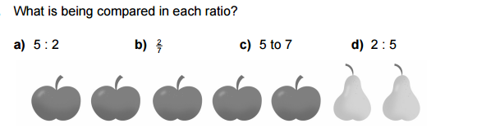

Thursday (Orders of Operation and Equivalent Ratios)

- 3 x 5 – 6 2. 8 – 9 x 2 3. 7 ÷ 1 x 11

