Monday:
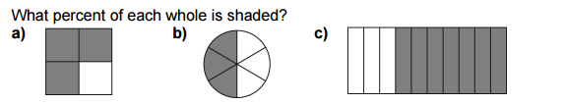

Percent: __________ Percent ________ Percent ________
Show Your work.

Tuesday:
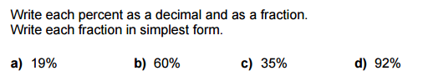

Wednesday
- When Ryan was buying her house she had to put down a deposit of of the value of the flat. What percentage is this?

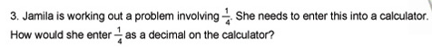
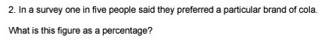

4. I bought my coat in the January sales with off the original price. What percentage was taken off the price of the coat?

Thursday:
Write your own word problem, relating fractions, percent’s and decimals. Then answer it! (Don’t forget to show your work)

