Monday:
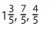
1. Place the following numbers on the number line.
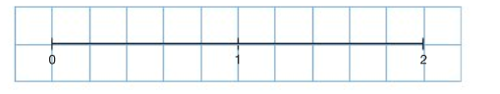

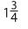
2. Place the following numbers on the number line.
(Remember to change them to equivalent fractions with the same denominator)
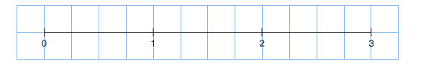

Show Work Here:

Tuesday:
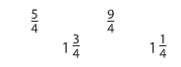
Convert the following numbers to either improper fractions or mixed numbers.

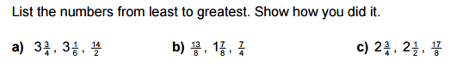
2.

Wednesday:
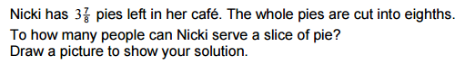
#1

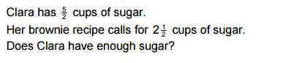
#2

Thursday: Write the first ten multiples of:
7
9

