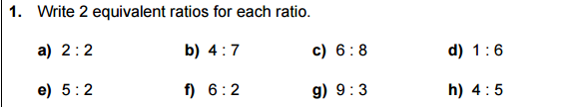

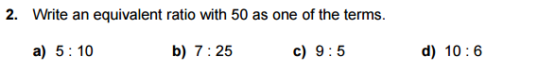

Tuesday:
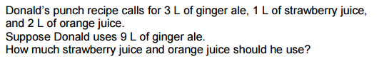

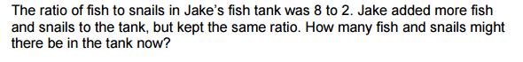

Wednesday:
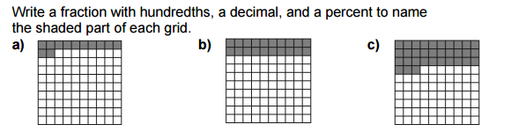

Thursday:
