Weekly Homework
April 25-29

MONDAY:
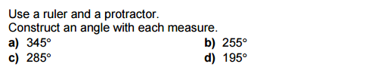

TUESDAY:
Word Problems (Show your work)

- Mrs. Moody bought 3 tickets to Justin Beiber. The total cost was $ 390.60. What was the cost of one ticket?

- Mr. Buggie bought a new volleyball for $35.45. What would be the cost of 5 volleyballs?

WEDNESDAY:

