MLA Formatting, Quote Citations, and Works Cited

MLA Formatting

Paper Format
- Type your paper on a computer and print it out on standard, white 8.5 x 11-inch paper,
- Double-space the text of your paper, and use a legible font like Times Roman. The font size should be 12 pt.
- Leave only one space after periods or other punctuation marks (unless otherwise instructed by your instructor).
- Set the margins of your document to 1 inch on all sides. Indent the first line of a paragraph one half-inch (five spaces or press tab once) from the left margin.
- Create a header that numbers all pages consecutively in the upper right-hand corner, one-half inch from the top and flush with the right margin and make sure the header includes your last name.
- Use either italics throughout your essay for the titles of longer works and, only when absolutely necessary, providing emphasis. CHANGE: No more underlining major works – only italicize!
- Do not make a title page for your paper unless specifically requested.
- In the upper left-hand corner of the first page, list your name, your instructor’s name, the course, and the date. Again, be sure to use double-spaced text.
- Double space again and center the title. Don’t underline your title or put it in quotation marks; write the title in Title Case, not in all capital letters.
- 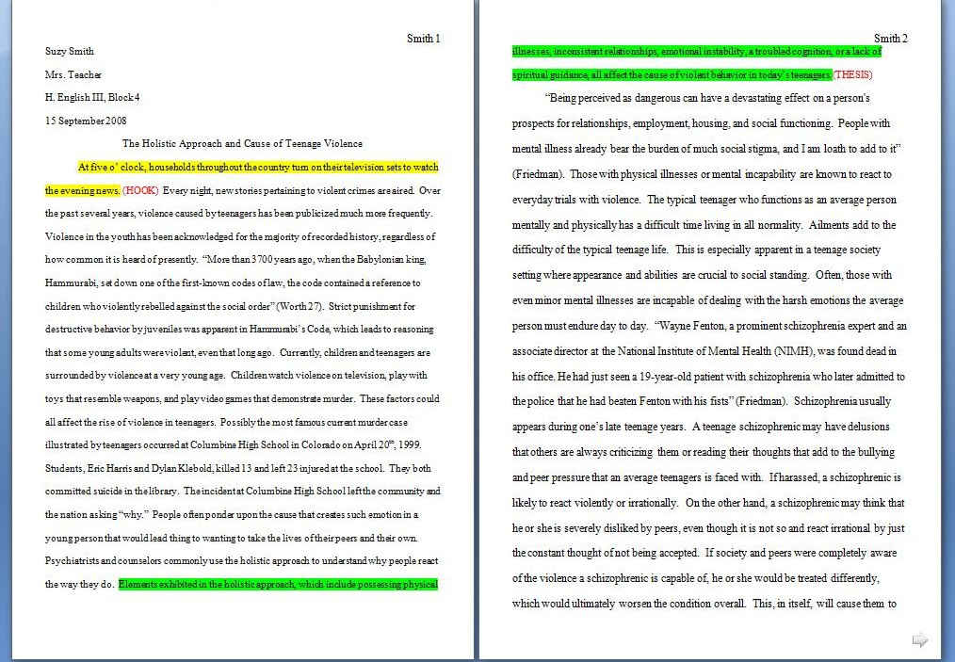

QUOTING.
There are three basic ways to quote:
*Summary – Summarize large chunks of what you read by recording the general idea of the material. Remember to record the page numbers (if applicable) where you found the information.
*Paraphrase – Read the work and restate all of the material in your own words. Remember to record the page numbers.
*Quotation – If what the speaker or author said was important in the exact order that he or she stated it, record the sentence(s) word-for-word as a direct quotation. Remember to put quotation marks around the sentence(s) to remind you later that it is a direct quotation. If you copy and paste phrases from an article, you should put quotation marks around what you copied to remind yourself that it’s a direct quote. Record the page numbers so that you will have them when completing the Works Cited page.
Please remember that ALL THREE REQUIRE PARENTHETICAL CITATIONS AND YOUR COMMENTARY.

HOW TO CREATE QUOTES AND PARENTHETICAL CITATIONS
1. Always introduce the quote.
2. If it is a direct quote, use beginning and ending quotation marks.
3. If you are paraphrasing, you still need to cite your source.
4. Always cite the quote using parentheses, author’s last name and pg #. In the case there is an author, use a shortened version of the title. If it is a short piece, the title is in quotation marks; if it is a long piece (like a book or journal) the title is italicized.
5. If your quote is more than 4 lines long, you must indent the entire quote three times.
6. Period are placed after the parenthetical citation, however question marks, commas, and exclamation points are placed within the quotation marks followed by a period after the parenthetical citation.
7. Always explain or reference the quote you use.
- Immediately following a quotation from a source or a paraphrase of a source’s ideas, you place the author’s last name followed by a space and the relevant page number(s). ** Parenthetical citations can vary depending on what information is included in the introduction of the quote. If you are writing the source’s ideas word for word, you MUST include quotation marks around those words; if you are summarizing or paraphrasing, you do NOT use quotation marks. Either way, you MUST include parenthetical citation.
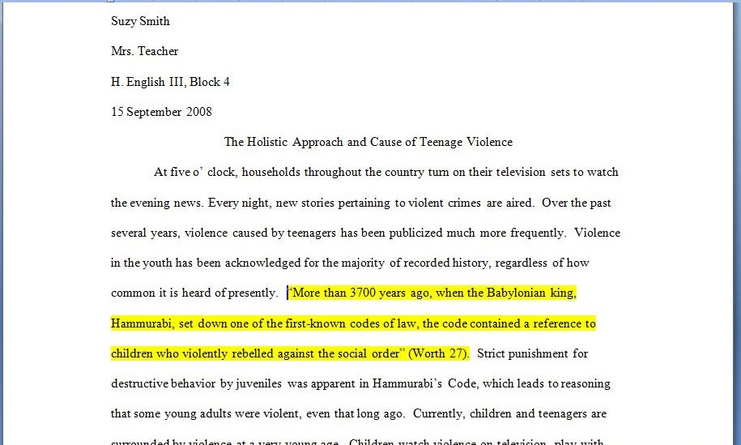
When a source has no known author, use a shortened title of the work instead of an author name. Place the title in quotation marks if it’s a short work, or italicize it if it’s a longer work.
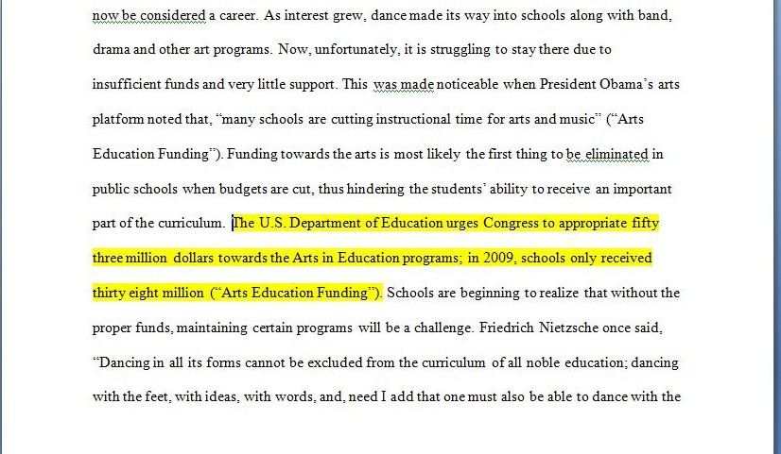
- To indicate short quotations (fewer than four typed lines of prose or three lines of verse) in your text, enclose the quotation within double quotation marks. Provide the author and specific page citation (in the case of verse, provide line numbers) in the text, and include a complete reference on the Works Cited page. Punctuation marks such as periods, commas, and semicolons should appear after the parenthetical citation.
- Question marks and exclamation points should appear within the quotation marks if they are a part of the quoted passage but after the parenthetical citation if they are a part of your text.
- For quotations that are four or more lines of verse or prose: place quotations in a free-standing block of text and omit quotation marks. Start the quotation on a new line, with the entire quote indented one inch from the left margin; maintain double-spacing. Only indent the first line of the quotation by a half inch if you are citing multiple paragraphs. Your parenthetical citation should come after the closing punctuation mark.
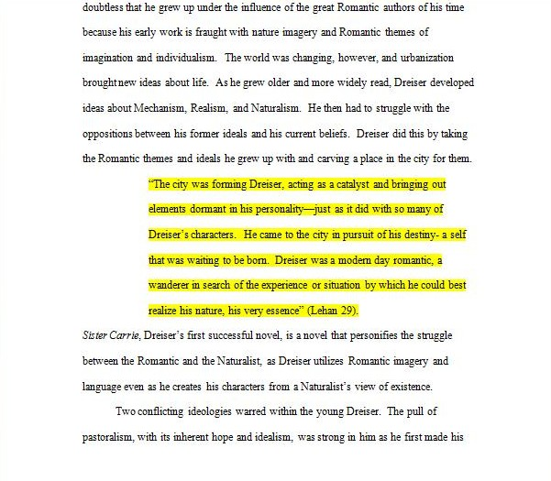

Works Cited
The Basic Format and Rules
1. The Works Cited is its own page and must have the title centered at the top. See the example for assistance.
2. Include a header on the right-hand side. (Your last name and appropriate page number.)
3. Double-space the page.
4. Indent the second line of the citation. This is called a hanging indent and can be accomplished by hitting “enter” and then “tab.”
5. Put the citations in alphabetical order.
6. Use italics instead of underlining for titles of larger works.
7. Capitalize each major word in the titles of articles, books, etc.
8. Omit the URL.
9. State the medium of publication (Print, Web, etc.).
- No More URLs! While website entries will still include authors, article names, and website names, when available, MLA no longer requires URLs. Writers are, however, encouraged to provide a URL if the citation information does not lead readers to easily find the source.
- Continuous Pagination? Who Cares? You no longer have to worry about whether scholarly publications employ continuous pagination or not. For all such entries, both volume and issue numbers are required, regardless of pagination.
- Publication Medium. Every entry receives a medium of publication marker. Most entries will be listed as Print or Web, but other possibilities include Performance, DVD, or TV. Most of these markers will appear at the end of entries; however, markers for Web sources are followed by the date of access.
- New Abbreviations. Many web source entries now require a publisher name, a date of publication, and/or page numbers. When no publisher name appears on the website, write N.p. for no publisher given. When sites omit a date of publication, write n.d. for no date. For online journals that appear only online (no print version) or on databases that do not provide pagination, write n. pag. for no pagination.
MOST BASIC BIBLIOGRAPHIC INFORMATION ORDER:
- Author and/or editor names (if available)
- Article name in quotation marks (if applicable)
- Title of the Website, project, or book in italics. (Remember that some Print publications have Web publications with slightly different names. They may, for example, include the additional information or otherwise modified information, like domain names [e.g. .com or .net].)
- Any version numbers available, including revisions, posting dates, volumes, or issue numbers.
- Publisher information, including the publisher name and publishing date.
- Take note of any page numbers (if available).
- Medium of publication.
- Date you accessed the material.
Hart, Samantha. “Ten Examples of MLA.” Journal of English Education. v 15 no. 2. JSTOR. 2008. Web.
15 March 2012.

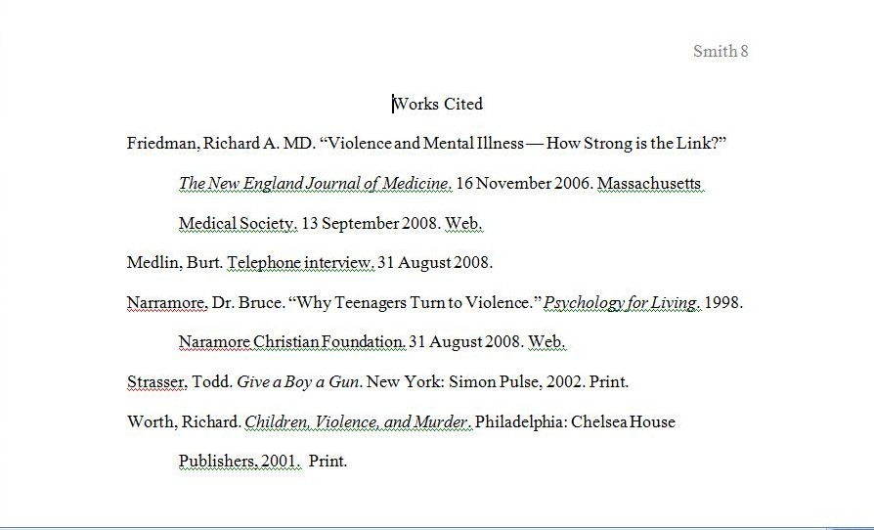
Another Example:
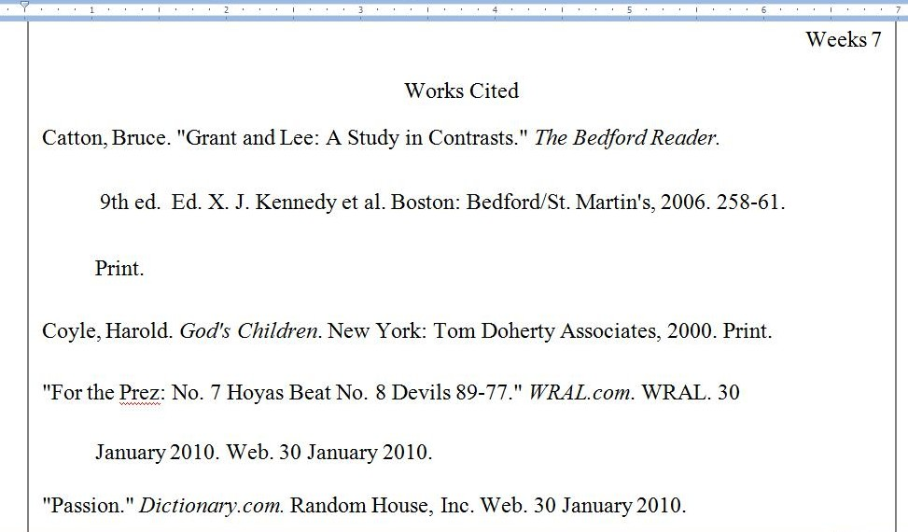
Other sites that have information in MLA formatting:
Purdue OWL

