Weekly Math Homework
April 18-22

MONDAY:
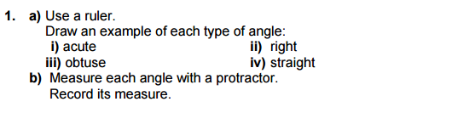

TUESDAY:
Orders of operation:

- 6 x 7 -2

- 50 +10 ÷ 2

- 7 + 4 -3

- 25 – 3 x 4
WEDNESDAY:
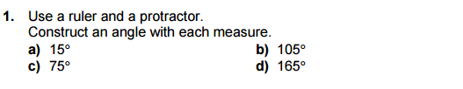

THURSDAY: Equivalent Ratio
Write 3 equivalent ratios for the following:

- 5 : 6

- 10 : 4

- 7 : 9

- 2 : 2

