Weekly Homework
April 11 -15

MONDAY:
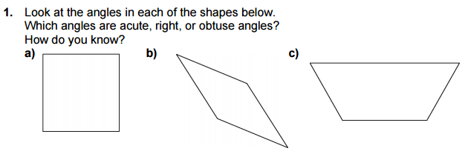

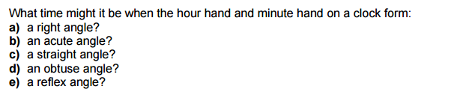
2.

TUESDAY:
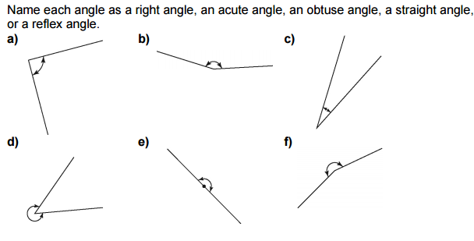

WEDNESDAY:

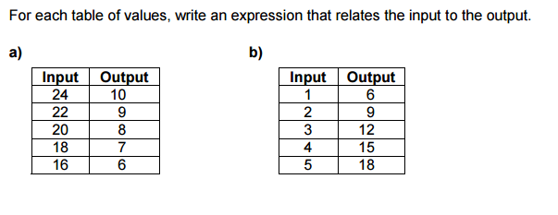
THURSDAY:
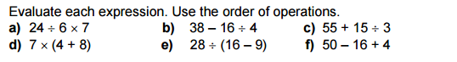

SHOW YOUR WORK BELOW

