Monday:
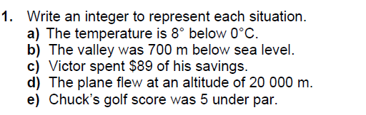
Answers:
- __________ B. __________ C. ___________ D. __________ E. __________

Tuesday:
a.

b.

c.

d.

e.

Wednesday:
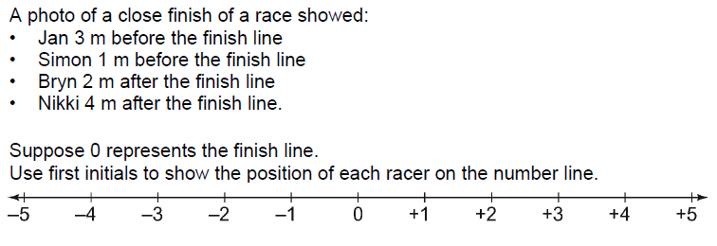

Thursday:
