Math Homework Sept 21 – 25
Parents/Guardian Signature: _______________________

MONDAY: 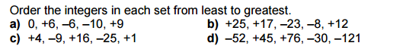
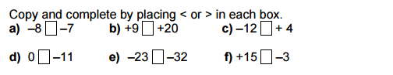

TUESDAY:
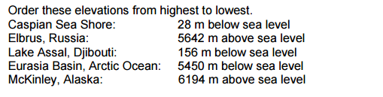

WEDNESDAY:
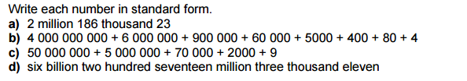

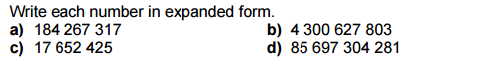

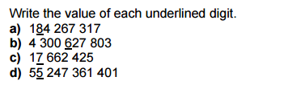
THURSDAY:

******DON’T FORGET LAST WEEKS CORRECTIONS******

