Weekly Homework
Sept 28 to Oct 2
Parents Signature: ___________________

MONDAY

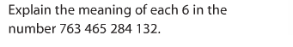

Tell me a real life situation when you would use:
- Written numbers

- Standard numbers

TUESDAY (You may use a calculator but show your work)
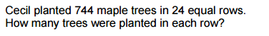

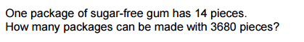

WEDNESDAY
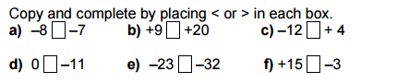

THURSDAY
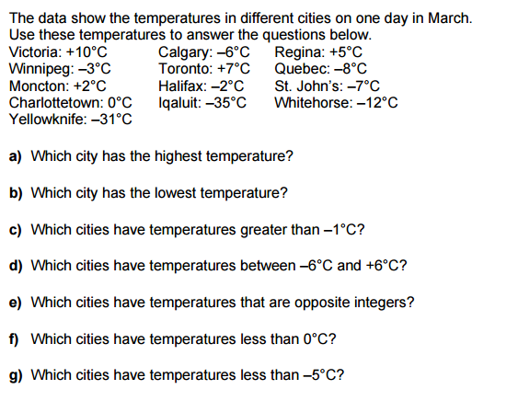
*** Don’t forget your corrections for the week of Sept 21 -25***

