Name: ______________________
Weekly Homework
November 9-13
Parents Signature: ___________________________
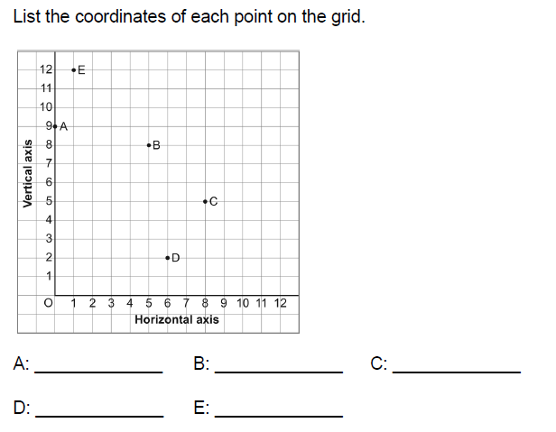
MONDAY:

TUESDAY
- Write the value of each underlined digit.

- 78 345
- 54 788 309
- 345 890 087

- Write a number that is:

- 100 000 more than 912 456
- 10 more than 45 698
- 1 000 000 than 34 567 900

__________________________________________________________________________________
THURSDAY:
- Describe whether the following data is discrete or continuous

- Bike helmets sold in the last 6 months _________________________

- Abby’s height from age 2 to 14 _______________________________

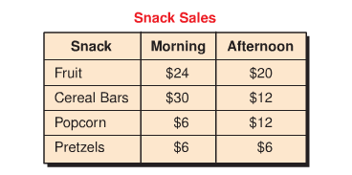
2 a. (YOU WILL NEED GRID PAPER)
- Decide on the appropriate graph.
- Create a graph
- Remember to label your graph appropriately
- Think about your scale

- Write 2 conclusions you can make from your graph.

- ____________________________________________________________________________

- ________________________________________________________________________

