Parents Signature: ________________________
Monday:
Timmy wants to buy a new game for his X-box. It costs $45. His mom will pledge $15, plus $5 for every job he does around the house.
- Make a table to show the amount Timmy needs to raise after completing 1, 2, 3, 4, and 5 jobs

- Write the pattern rule that relates the amount given to the number of jobs worked.

- Write an expression to represent the pattern.

Tuesday:
Evaluate the following expressions:

- 5 x 6 – 3 =

- 8 x 7 – 7 + 4 =

- 6 3 + 4 x 8 =
- 4 + 3 x 6 – 2 =

- 6 x 3 x 1 =

- 15 + 6 – 8 x 2 =

Wednesday:
Find the common factors of each pair of numbers

- 10, 15

- 18, 42

Draw 2 different factor trees for each number

- 48

- 36

Thursday:
Complete the following graph.
Include the following:
- Title, labels for both horizontal and vertical axis
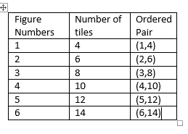
- Choose an appropriate scale (Count by 2’s, 5’s, 10’s)
- Describe the relationship shown on the graph
- Write an expression to represent the pattern

Show answers to questions here:

