MONDAY: Multiple Choice
- Seventy million, four hundred thousand, two. What does this number look like in standard form?
- 7 400 002
- 70 400 002
- 74 000 200
- 70 402

- What situation would best describe a negative integer?

- Above 0
- At ground level
- 20 below
- None of the above

- Which is the correct answer for the following order of operation: 2 + 7 x 3 =?

- 27
- 30
- 16
- 23

- Which set of numbers are prime?

- 4, 2, 47, 6
- 1, 2, 3, 5
- 11, 2, 3, 7
- 8, 24, 30, 9

- -7 -12

  - >
  - <
  - =
  - /

TUESDAY:
Orders of Operation.

- 7 – 4 + 4 b. 7+ 4 x 8 c. 9 – 1 + 7

- 9 + (9 – 1) f. 8 8 x 4 g. 7 x 8 8 -2

The pattern rule that related the input to the output is: multiply the input by 5, then subtract 1

- Write the pattern rule for the input.

- Write the pattern rule for the output.

- The pattern continues. Write the next 4 input and output numbers.
Input | Output
2 | 9
4 | 19
6 | 29
8 | 39

WEDNESDAY:
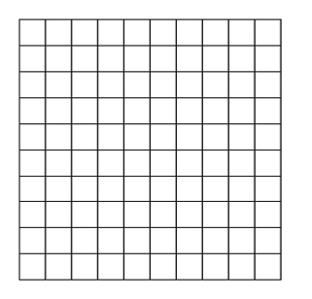
- Label your graph
- Make a title for your graph
- Make 2 conclusions from your graph
- What type of data is shown?
Days of the Week | Mon | Tues | Wed | Thurs | Friday
Temperature C | 3 | 7 | 2 | 11 | 15

Conclusions:

- Label your graph
- Make a title for your graph
- What type of data is shown?
- Make two conclusions from your graph
Middle School  Homeroom’s | Number of Students
Mrs. Moody | 26
Mrs. Waugh | 15
Mrs. Davidson | 15
Mrs. Burns | 16
Mrs. Duffy | 14

