Review for Week of May 11 to 15

Monday:
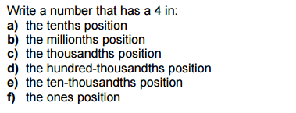

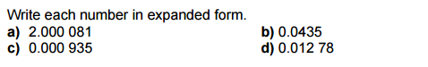

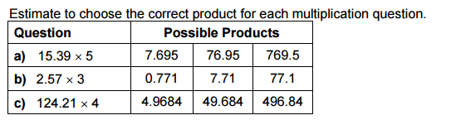
Tuesday:

- Estimate and multiply

Wednesday:
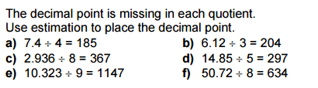
1.

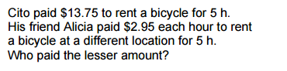
2.

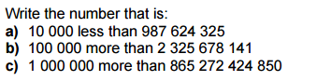
Thursday:

