Review #4
Name: ______________________

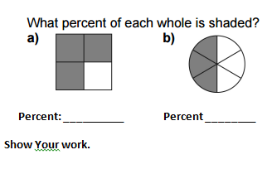

Write 5 equivalent ratios for the following ratios.
- 5 : 7 b. 2 : 9 c. 1 : 2 d. 4 : 6

