Name: _________________________ Parents Signature: ___________________________
Monday:
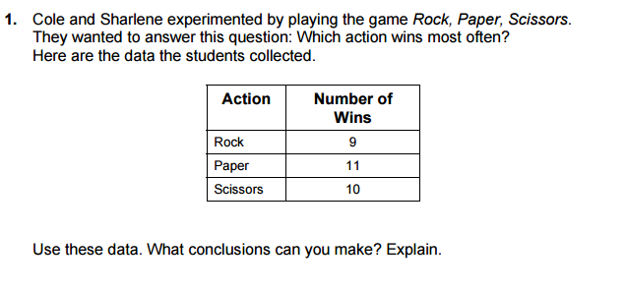

Tuesday:

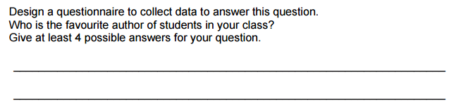

2.

Tuesday:
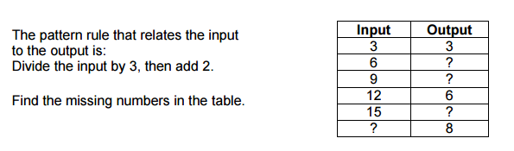

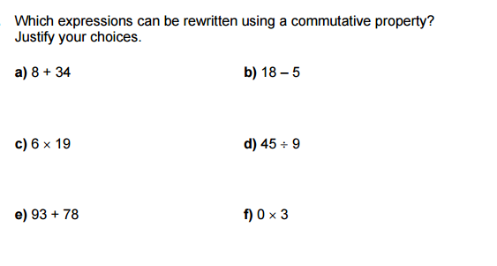

Wednesday
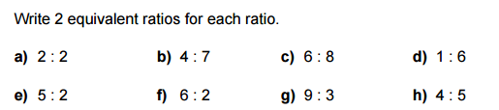

Thursday
