Name: _________________________ Parents Signature: ___________________________
Monday:
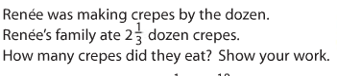

Tuesday:
Write the following integers in order from LEAST to GREATEST

- -7, 4, -9, 0, 3, 10

- 9, , 5, -2, -4, 8

- –13, -7, -3, -11, -6, 0

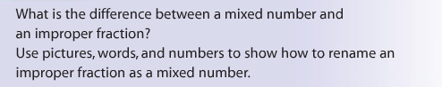
Wednesday:

HAPPY EASTER!!!!!

