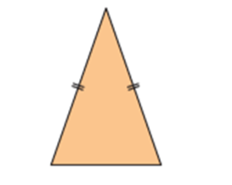



Isosceles Triangle

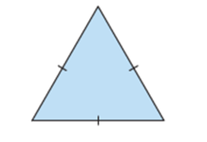



Equilateral Triangle

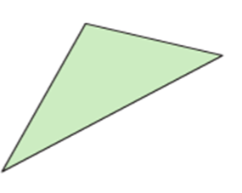

3.

Scalene Triangle

ISOSCELES TRIANGLE

* Has two equal sides
* Has two equal angles
* 1 line of symmetry
* Hatch marks show the equal sides

EQUILATERAL TRIANGLE

* Has three equal sides
* Has three equal angles
* 3 lines of symmetry
* Hatch marks show the equal sides
* All equilateral triangles have angle measures of 60 degrees.

SCALENE TRIANGLE

* Has no equal sides
* Has no equal angles
* Has no lines of symmetry