Name: _____________________ Parent/Guardian Signature; ______________________

**MONDAY:**

**List 3 attributes for each triangle and draw it. (Be neat and use a ruler)**

**EQUILATERAL TRIANGLE**

1. _____________________________________________________________
2. _____________________________________________________________
3. _____________________________________________________________

**ISOSCELES TRIANGLE**

1. ____________________________________________________________
2. _____________________________________________________________
3. _____________________________________________________________

**SCALENE TRIANGLE**

1. ____________________________________________________________
2. ____________________________________________________________
3. ____________________________________________________________

**TUESDAY:**

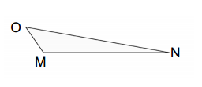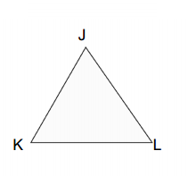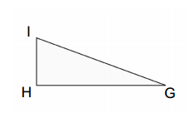**Measure the angles in each triangle and name each triangle as acute, obtuse or right**

**Wednesday:**

1. **Evaluate each expression. (Use the order of operations rules)**
2. 3 + 5 x 7 = b. 10 – 6 + 2 = c. (12 – 4) x 4 =
3. **Draw a factor tree for the following numbers:**

i) 32 ii) 81

1. **Define the following: (use words and numbers)**
2. Composite numbers:
3. Prime numbers:

**Thursday:**

1. **List the factors of 36 (hint: use a rainbow or organized list to help you)**
2. **List 10 multiples of 5**
3. **Find the first 2 common multiples of 4 and 8**