Name: _____________________ Parent/Guardian Signature; ______________________

**MONDAY:**

1. **Order the integers from greatest to least**
2. **+6, 0, -3, +2,-7 b. -3, -6, -4, -8, -2 c. 9, 4, -1, -2, 3**
3. **Complete by placing <, >, or = between the integers.**
4. **– 5 -5 b. +12 10 c. -2 -8 d. 9 8**
5. **Describe a situation that could be represented by each integer.**
6. -10
7. +3
8. -7

**TUESDAY:**

1. **Write each number in standard form.**
2. **11 000 000 +600 000 + 3000 + 4**
3. **Six million four hundred thousand four hundred eighty**
4. **Write each number in expanded form.**
5. **33 333**
6. **9 350 350**
7. **223 337 453**

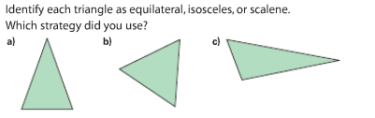**WEDNESDAY**:

1.

____________________ _____________________ ________________________

1. Strategy: _____________________________________________________________
2. Strategy:

_____________________________________________________________

1. Strategy:

_____________________________________________________________



2.

____________________________________________________________________________________________________________



____________________________________________________________________________________________________________

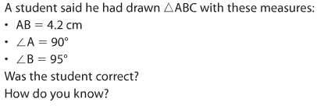**Thursday:**

**______________________________________________________________________________________________________________________________________________________________________________**