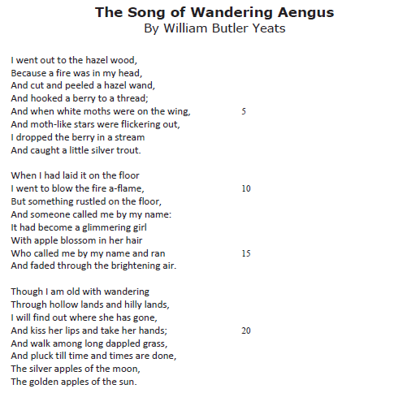

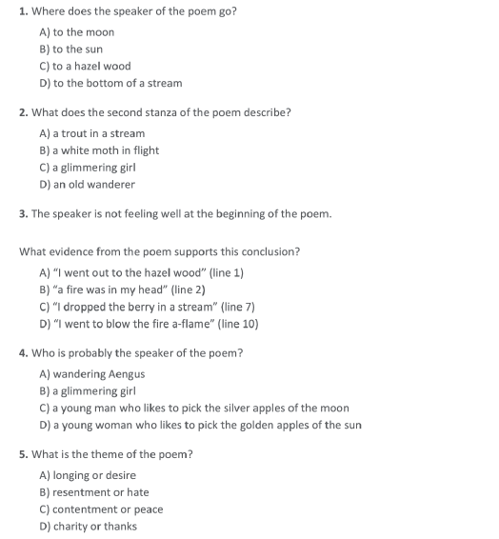

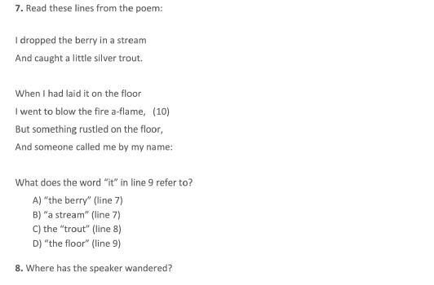

________________________________________________________________________________________________________________________________________________

________________________________________________________________________________________________________________________________________________

(Evidence)
________________________________________________________________________________________________________________________________________________________________________________________________________________________________________________________________________________________________

